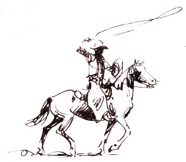
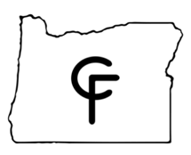

Friday, September 16, 2022
Cascades Futurity & Aged Event
TEAM RANCH BRANDING ENTRY FORM
- Teams – Four team members must be named on each entry.
- Time Limit – Two calves branded in (2) minutes and thirty (30) seconds.
- There will be a mandatory contestant’s meeting in the arena prior to the competition.
- Any unnecessary roughness to cattle will be an immediate disqualification and will be STRICTLY enforced.
- Must change at least 2 members of the team for additional teams.
- All contestants MUST sign a liability release prior to event, no exceptions!

- Please visit the www.cascadesfuturity.com website for a full list of rules and regulations for the event.

- ENTRY FEES: Due at show - $200 per team or $50 per individual / Open
$100 per team or $25 per individual / Non-Pro
CHECK ONE: OPEN ________________ Non-Pro _______________
Team Captain:
Phone #:
TEAM #1 - RIDER #1:
RIDER #2:
RIDER #3:
RIDER #4:
TEAM #2 - RIDER #1:
RIDER #2:
RIDER #3:
RIDER #4:

By submitting this entry form I agree to all the rules and regulations, terms and conditions of the Cascades Futurity and Limited Aged Event Branding Event. A signed liability form must accompany this form.

_________________________________________ _____________________
Signature Date

